Lesson 2 Teacher Reference

Making Sugar Glass

Below are instructions on how to make sugar glass in a rectangular 2” x 3” size that is approximately 1/16” thick. The sugar glass is an analog for cell phone screens.

Refer to the Materials Preparation section of the Teacher Guide for specific directions about how to use the sugar glass after it is made. To help you plan, the following table outlines how many pieces of sugar glass you’ll need for each lesson per class (based on six groups of students in a class). You will need to multiply the total per class by how many classes you teach to arrive at the grand total number of sugar glass pieces you’ll need to prepare altogether. You may want to prepare 20% extra for accidental breakage.

Number of sugar glass pieces needed
Lesson | Per student | Per pair | Per group | Per class for whole-group demonstration | Total for one class (based on 30 students in 6 groups)*
2 |  |  | 1
5 |  |  | 4

Adjust if you have more or fewer than 30 students per class. Then, multiply this number by the number of classes you teach to plan how many pieces of sugar glass you need to prepare altogether.

To make the sugar glass, you will need the following:
- 1 1-lb bag of Arcor Crystal Mints (note: You may also use Matlow's Hard Mint Candy or Jolly Ranchers, however, melting times may vary slightly.)
- 1 6-cavity silicone soap mold measuring approximately 3” x 2” x 1” per cavity
- 1 cookie sheet
- 1 cooling rack
- 1 can of nonstick cooking spray
- 1 resealable, plastic storage bag, gallon size
- an electric or gas oven
- 1 roll of wax paper
- paper towels
- 2 oven mitts or hot pads
- 1 splash goggles

The directions for preparing this recipe are shown here, and you may also watch a video demonstration at https://youtu.be/-jYT577_CAM. The total time to prepare the sugar glass is around 25 minutes. The active time is 10 minutes.

Preheat your oven to 325 ℉ Place the silicone mold on a cookie sheet Put a quick, quarter-sized squirt of nonstick cooking spray in the middle of each cavity in the mold. Use your fingers to spread the spray around the bottoms and sides. Make sure that none of the spray is pooled in the corners. Remove excess spray by wiping with a paper towel. | 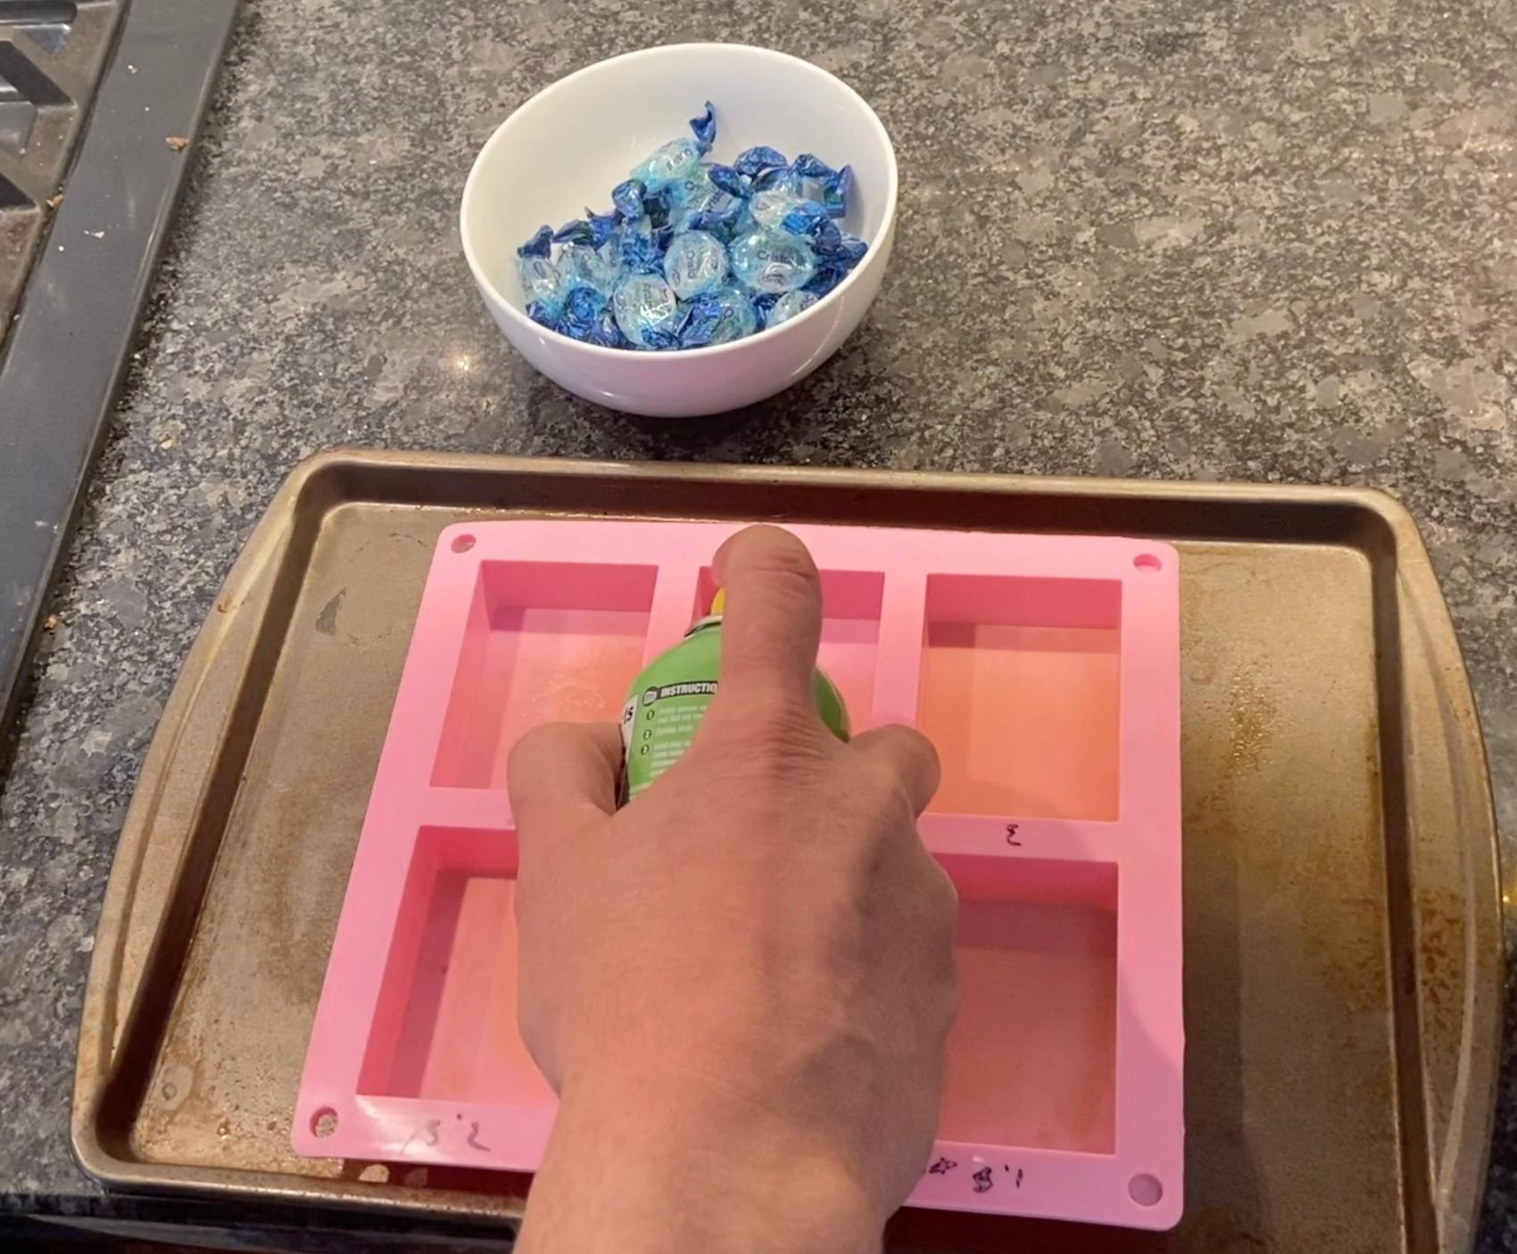
Place 2 unwrapped candies in each cavity. Make sure the candies are spaced evenly in the cavities and not touching the sides. | 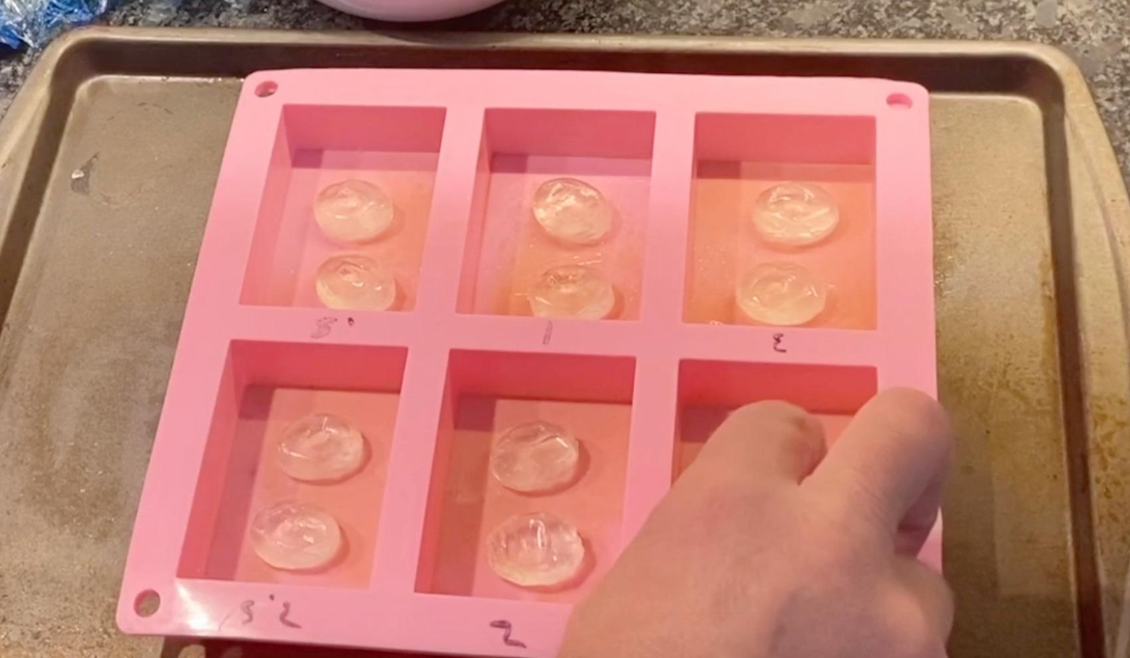
Place the cookie sheet and mold on the middle rack of your oven. | 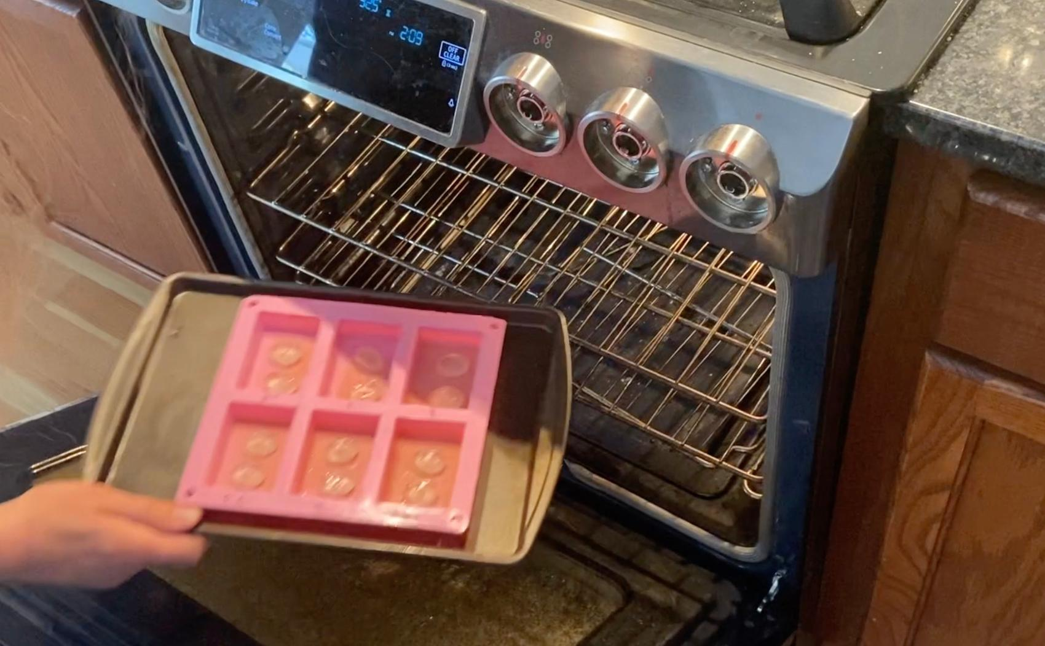
Caution: Melted sugar can cause severe burns. If it gets on the skin, it will stick to the skin and continue to burn until you take appropriate countermeasures. Follow these safety precautions when taking the melted sugar out of the oven in the next steps: Wear splash goggles. Make sure you have feet, legs, and arms covered (e.g., closed-toed shoes, long pants, and long-sleeve shirt). Use oven mitts to remove the cookie sheet and mold containing the melted sugar. Have cold water handy in case any melted sugar gets on your skin. If hot sugar burns skin, place skin in cold water (not ice). If done within the first minute or so, cold water immersion for up to 30 minutes can reduce total area and severity of the burn.
After approximately 15 minutes, the candy will melt, bubble, and fill the mold. (Note: this time will vary based on your oven and the candies used.) Remove the cookie sheet and mold from the oven and set it on the cooling rack. The melted candy should fill the entire mold after about 10 seconds. Some bubbles are normal. If it does not, place them back in the oven for another 2 minutes. | 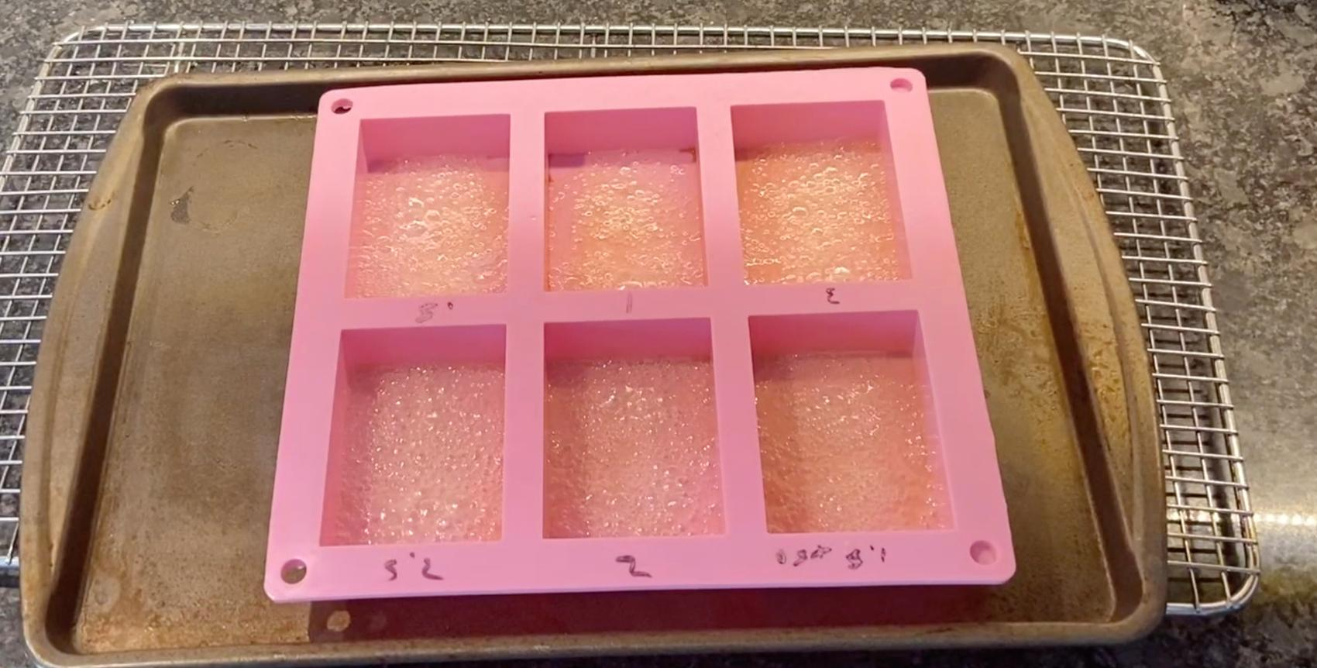
In approximately 10 minutes, the sugar glass will have cooled and hardened. Gently remove the sugar glass by pushing on the back of the molds. | 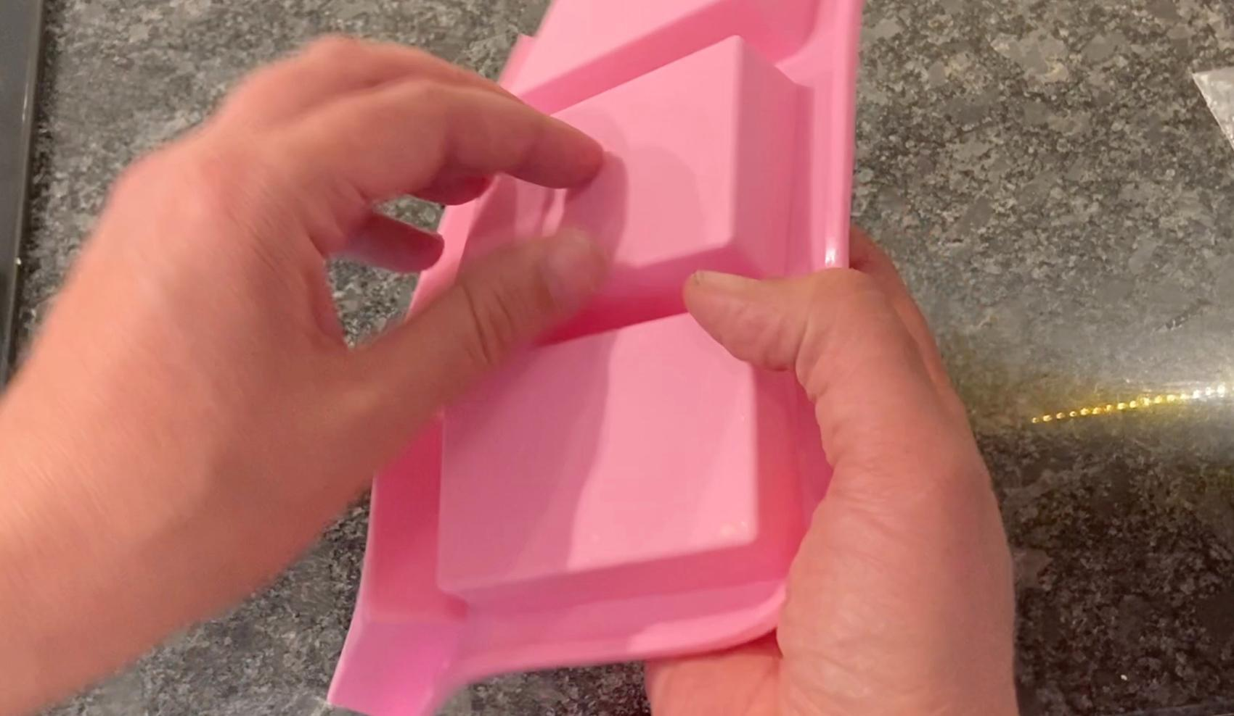
Stack the sugar glass between pieces of wax paper and place in a sealable plastic bag until ready to use. | 